DEPARTMENT OF Life Sciences

PHYSIOLOGY
LABORATORY 1

Measurement (26pts)
Introduction:
Many persons raised in the United States have only an abstract understanding of the metric system and are without the ability to make rough estimates of metric quantities. Meter is the fundamental unit of length in the International System of units (SI unit symbol, m). Centimeter (cm) is a unit of length equal to one hundredth (1/100) of a meter. In this lab it is worth taking the time to gain an understanding of these measures (meter and centimeter) with respect to a standard we have worked with our whole lives, our own bodies. Meter and centimeter measures of the human body will be found and these rough estimators of length will be used to make estimates of length, area and volume. Our primary purpose is however to work with/demonstrate some concepts associated with measurement, experimental technique, accuracy and precision which are embodied in the scientific method. We will learn that the value obtained in a measurement is very much dependent on the instruments and the procedures used to obtain that value.

Purpose:
We will conduct an exercise to familiarize ourselves with metric measures of distance. We will apply these measures to human characteristics, and consider the importance of variation in physiology.

Precision and Accuracy:
The goal of an experiment is to obtain a measurement (best expressed in numbers) which reflects the quantity one wishes to measure in a manner which can be repeated. Precision and accuracy are two important points in measurement. Precision refers to the ability of a measurement to be consistently reproduced. Precision measures the spread of measurements in repeated experiments under the same conditions. Accuracy is how close your measured result is to some hypothetical "true" value. Figure 1 graphically displays both concepts.
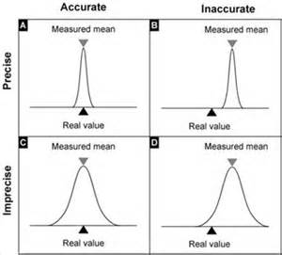

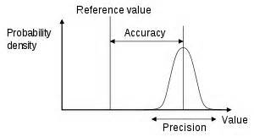

Fig. 1a (from en.wikipedia.org) Fig. 1b (from microarrays-holstegelab.nl)

Figure 1: The distribution of measurements taken by an experimenter. The curve shows a distribution of values obtained after many identical measurements. Also displayed are graphical representations of precision and accuracy.

Activity 1: Discrete Variables (2pts)
Definition of discrete variable: a variable that takes values from a finite or countable set, such as the legs of an animal (from English dictionary). At intervals to be determined count the number of students in this class. You will need to discuss what it means for a student to be "in class," for instance is a student on break "in class?" Once you have your definition your group will need to determine a minimum time interval between counts. Pick a number greater than 10 minutes. When you have at least 10 separate counts find the average number of students over all trials. What significance do fractional numbers of students represent?

Activity 2: Metric estimates (2pts)
Take a meter stick and find a point on your body one meter from the ground. Take note of where this point is as you will be using it as a rough measure of vertical distance. For horizontal distance spread your arms wide, held straight out from your body. Obtain a rough measure in the horizontal direction by measuring one meter from your finger tip across your body. Take note of this point as well. Obtain estimators for five and one centimeters in the same manner. Use the back of your hand for this. Make a diagram to illustrate where each measure falls on your body.

Activity 3: Predictions (2pts)
Consider the people in your group. Without lining people up or doing a direct comparison, rank the people in your group from shortest to tallest, based on your expectations. Do this individually, and do not share this information with your group members. Also make a prediction. You will be measuring wrist circumference as well. Do you think this will correlate with height? If so, will there be any deviations?

Activity 4: Using your metric estimates (16pts)
This next portion of this activity does not involve the use of a meter stick. Have each individual use these rough measures of one meter and smaller units to estimate the height and wrist circumference of each person in your group. In order to ensure independent measurements, your group will need to arrive at some procedure which will allow each lab partner to measure the height of each person without knowing the results obtained by others.

Heights: (2pts)
Name- Or Pseudo | 1. | 2. | 3. | 4.
1.
2.
3.
4.

Wrists: (2pts)
Name or Pseudo | 1. | 2. | 3. | 4.
1.
2.
3.
4.

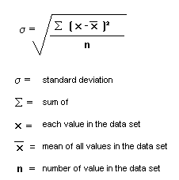
For each person, calculate the average, or mean (add up all the measurements, and divide by the number of measurements) and the standard deviation.

Then measure the height of each person in your lab group using a meter stick. To measure the wrist circumference, wrap a piece of string around their wrist and then measure the string by using the meter stick.

Record both measurements as “actual” in the tables below.

Heights: (2pts)
Name or Pseudo | Mean | Standard Deviation | Range | Actual

Wrists: (2pts)
Name or Pseudo | Mean | Standard Deviation | Range | Actual

Q1: Did your group arrive at any divergent values? If so did a misunderstanding of method, purpose or intent give rise to this result? How might explicit procedures and discussion beforehand prevent different operators from arriving at wildly different measurements? (2pts)

Q2: How do the averages compare to the individual measurements and the actual measurement? Why might the average be preferred to the result of any single measurement? (2pts)

Q3: The range and the standard deviation are both measures of the spread of your data. Which shows the least sensitivity to extreme values? (2pts)

Q4: To what extent does any single measurement reflect a similar measurement taken by another person using similar tool and methods? Can we ever know the True value of a variable such as the length of a table or must we content ourselves with estimates which are both accurate and precise? (2pts)

Activity 5: Precision and Variation (4pts)
Given the results above, we understand that all measurements have some degree of uncertainty. However, sometimes there is also real variation in your data. Calculate the mean and standard deviation of the heights and wrist circumferences of your group (use each individual as one data point).

Q5: What does the standard deviation represent here? (2pts)

Q6. In reality, when you measure a set of samples, you don't know how much variation is due to uncertainty and how much is real population variance. What can you do to help determine this? (2pts)

